

**Higher Diploma in MECHANICAL &**

**ELECTRICAL Engineering**

Module Name:

ANALYSIS AND DESIGN OF ELECTRICAL CIRCUIT

STUDENT NAME:

KAMAIYA DHARMARAJ

STUDENT ID:

HDMEEJan23-3

Question 1

Derive the equation of total resistance, if the three resistors are connected in

a) Series

b) Parallel

Series Combination:

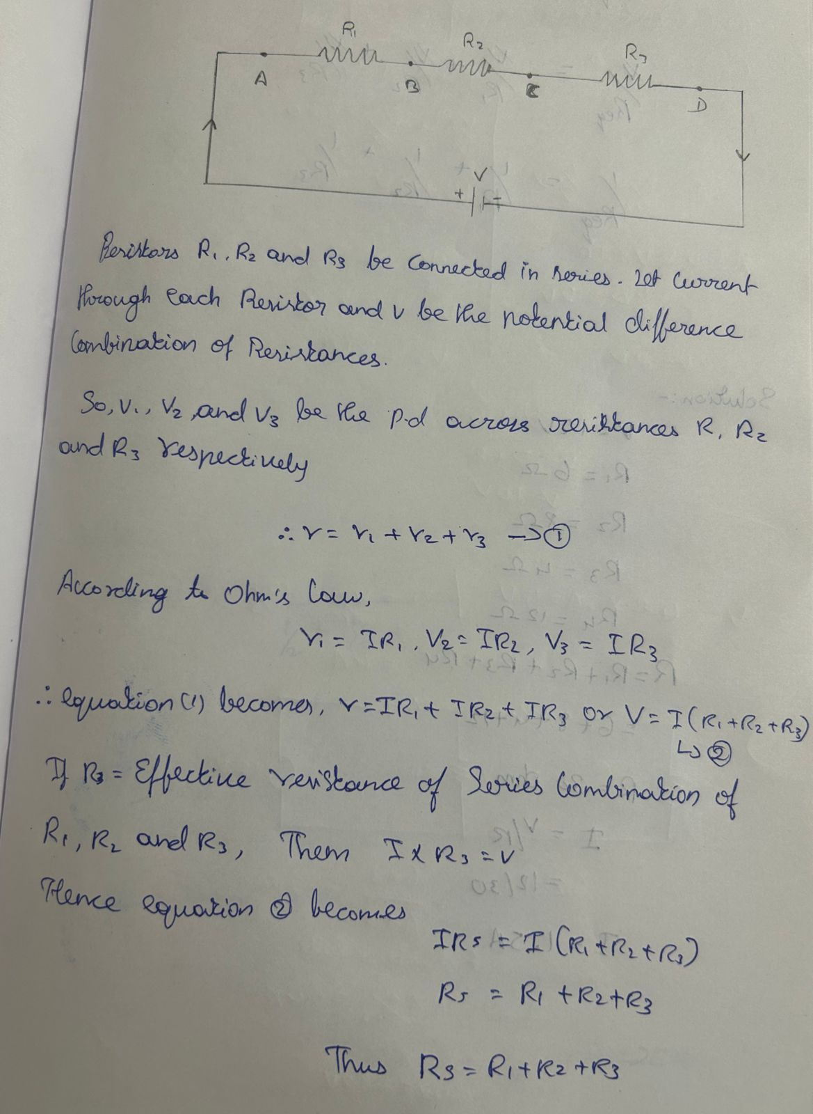

• The current flowing through them is .

• In series combination, the potential difference divides among the resistors, the sum of which will be equal to the total potential difference V applied across the combination.

• Thus, V=V1+V2+V3.......(a)

• we also know that,

• V=I⋅R (from ohm's law)

• ∴ IReq=IR1+IR2+IR3 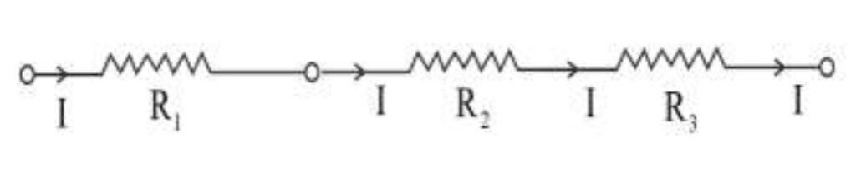

• IR = I(R₁+R₂+R₃)

• This gives, R = R₁+R₂+R₃ for series combination.

b) Parallel combination

• In parallel combination, we know that distribution

of current occurs across each resistor. Let Current

across each resistor R₁, R₂ and R₃ be I₁, I₂ and I₃.

• Hence, total current would be:

• I = I₁+I₂+I₃

• V/R=V/R1+V/R2+V/R3

• V/R=V(1/R1+1/R2+1/R3)

• For parallel combination,

• 1/R=1/R1+1/R2+1/R3

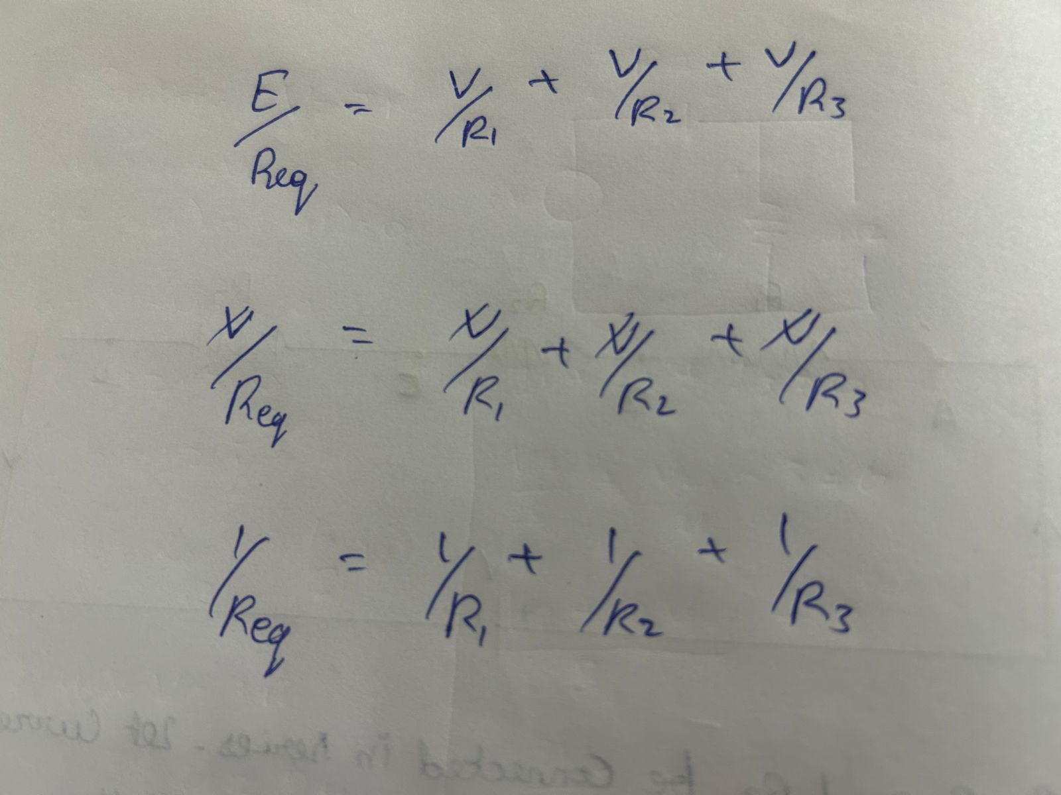

Question 2

In the following circuit calculate the total current (IT) taken from the 12v supply.

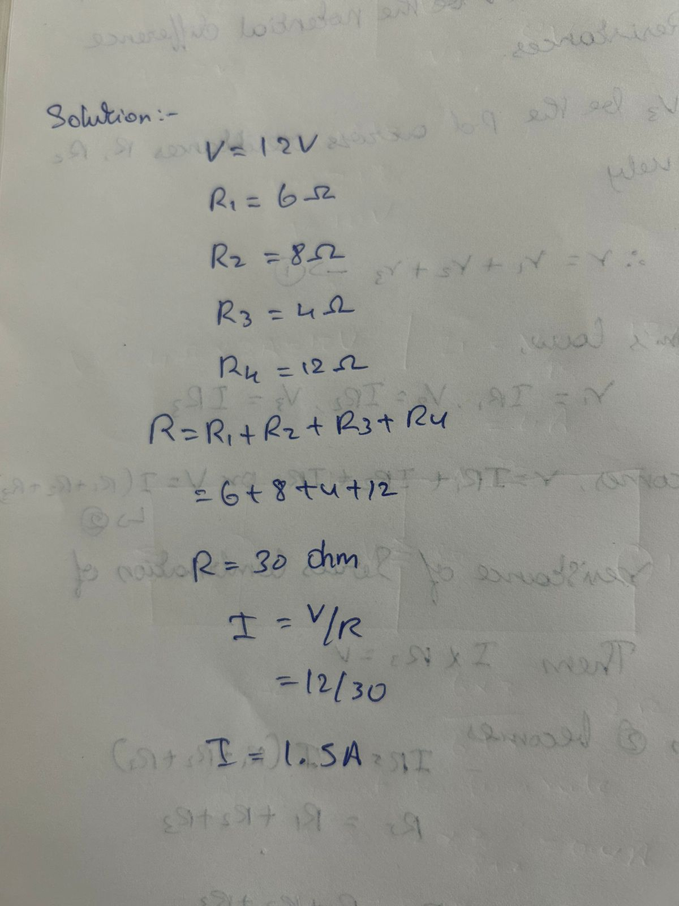

Question 3

Using the voltage divider rule find the voltage across each resistor

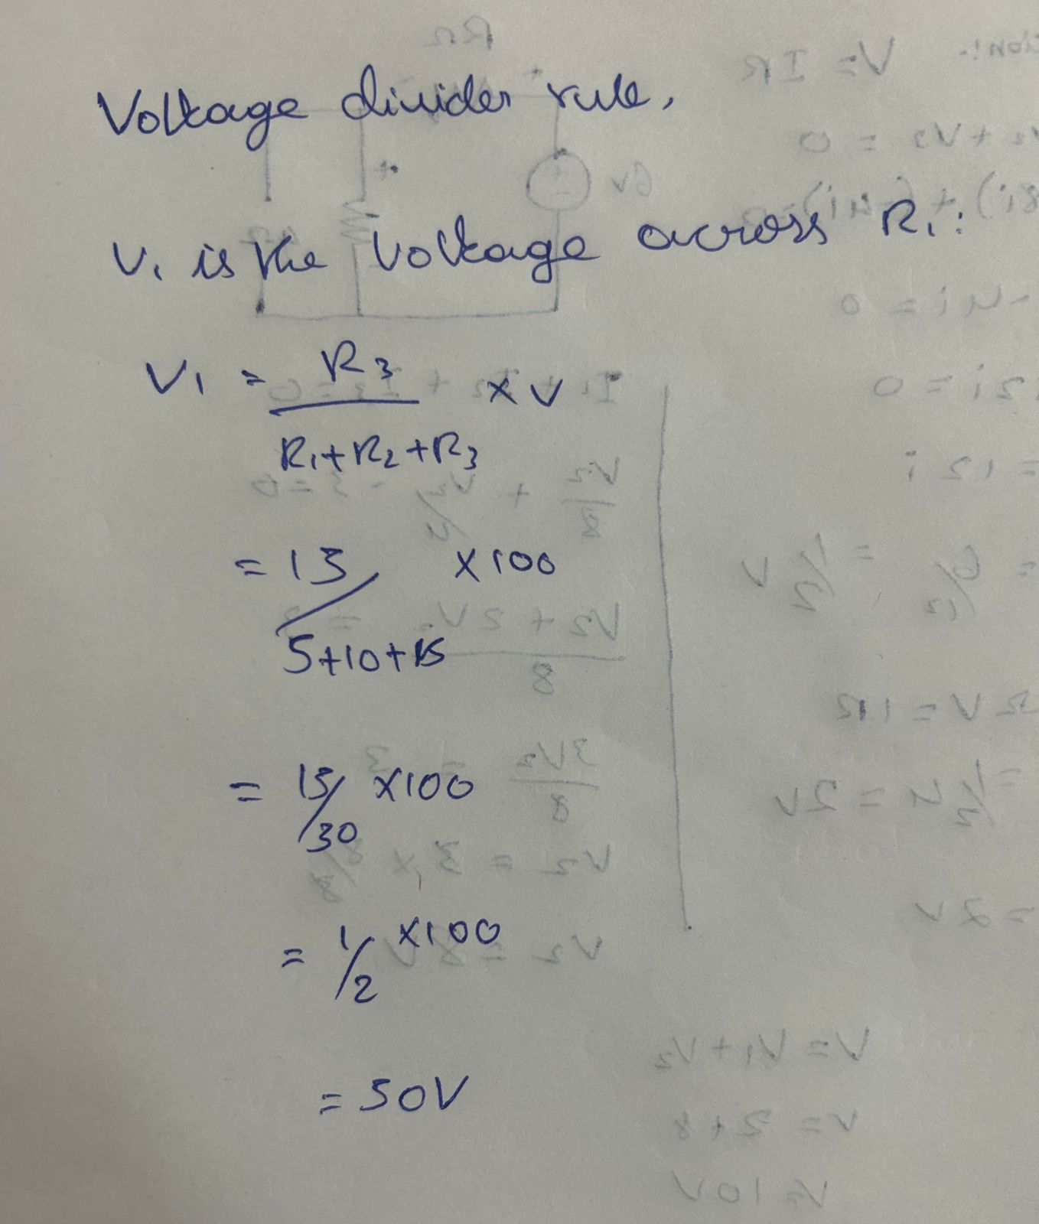

Question 4

Find the current through R1, R2 and r3 using current divider rule

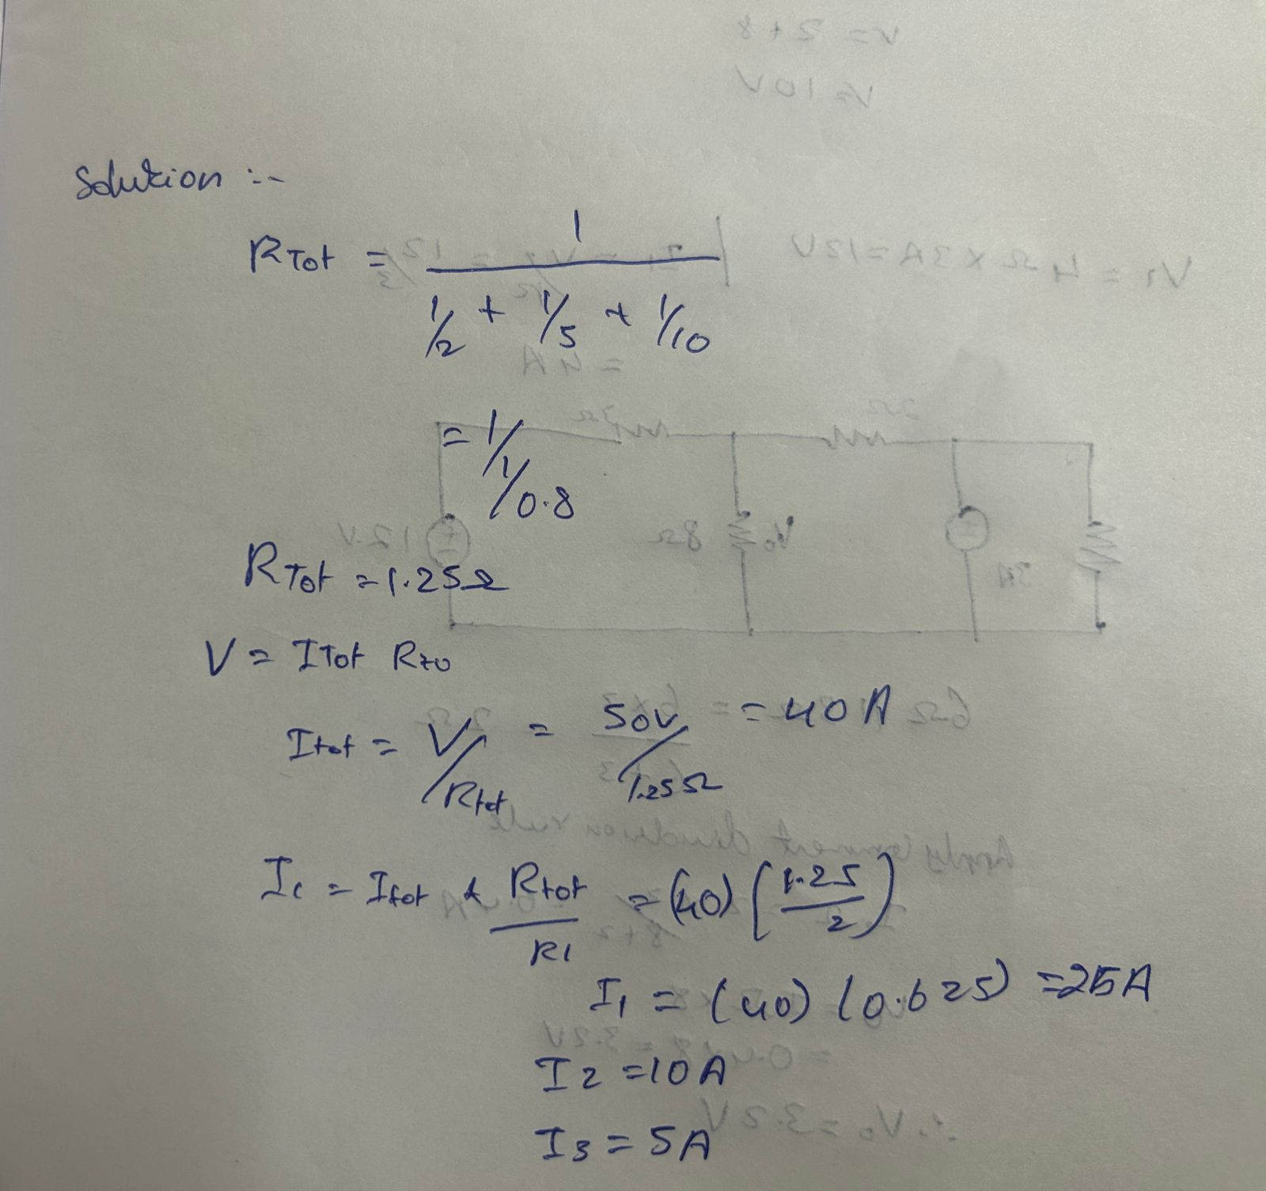

Question 5

Explain Kirchhoff’s law

developed a pair of laws that deal with the conservation of current and energy within electrical circuits. These two laws are commonly known as Kirchhoff’s Voltage and Current Law. These laws help calculate the electrical resistance of a complex network or impedance in the case of AC and the current flow in different network streams. In the next section, let us look at what these laws state.

Step 1. Statement of Kirchhoff's Law

1. The principle of this law is to conserve the electric charge.
2. There are two laws related to Kirchoff's Law.

Step 2. Kirchhoff law of Current

1. The principle of this law is to conserve the electric charge.
2. The law states that the amount of current flowing into a node is equal to the sum of currents flowing out of it.
3. In other words, the algebraic sum of all the currents in any given circuit will be equal to zero

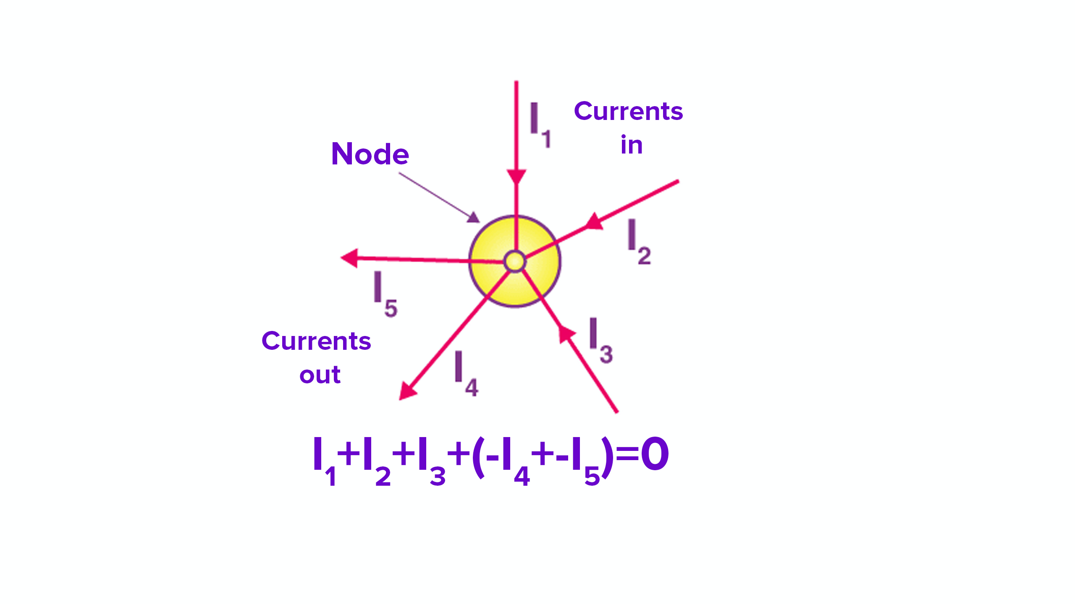

Step 3. Kirchhoff law of voltage

The principle of this law is to conserve energy.

The law states that the sum of voltages in a closed loop is zero.

The total amount of energy gained is equal to the energy lost per unit charge.

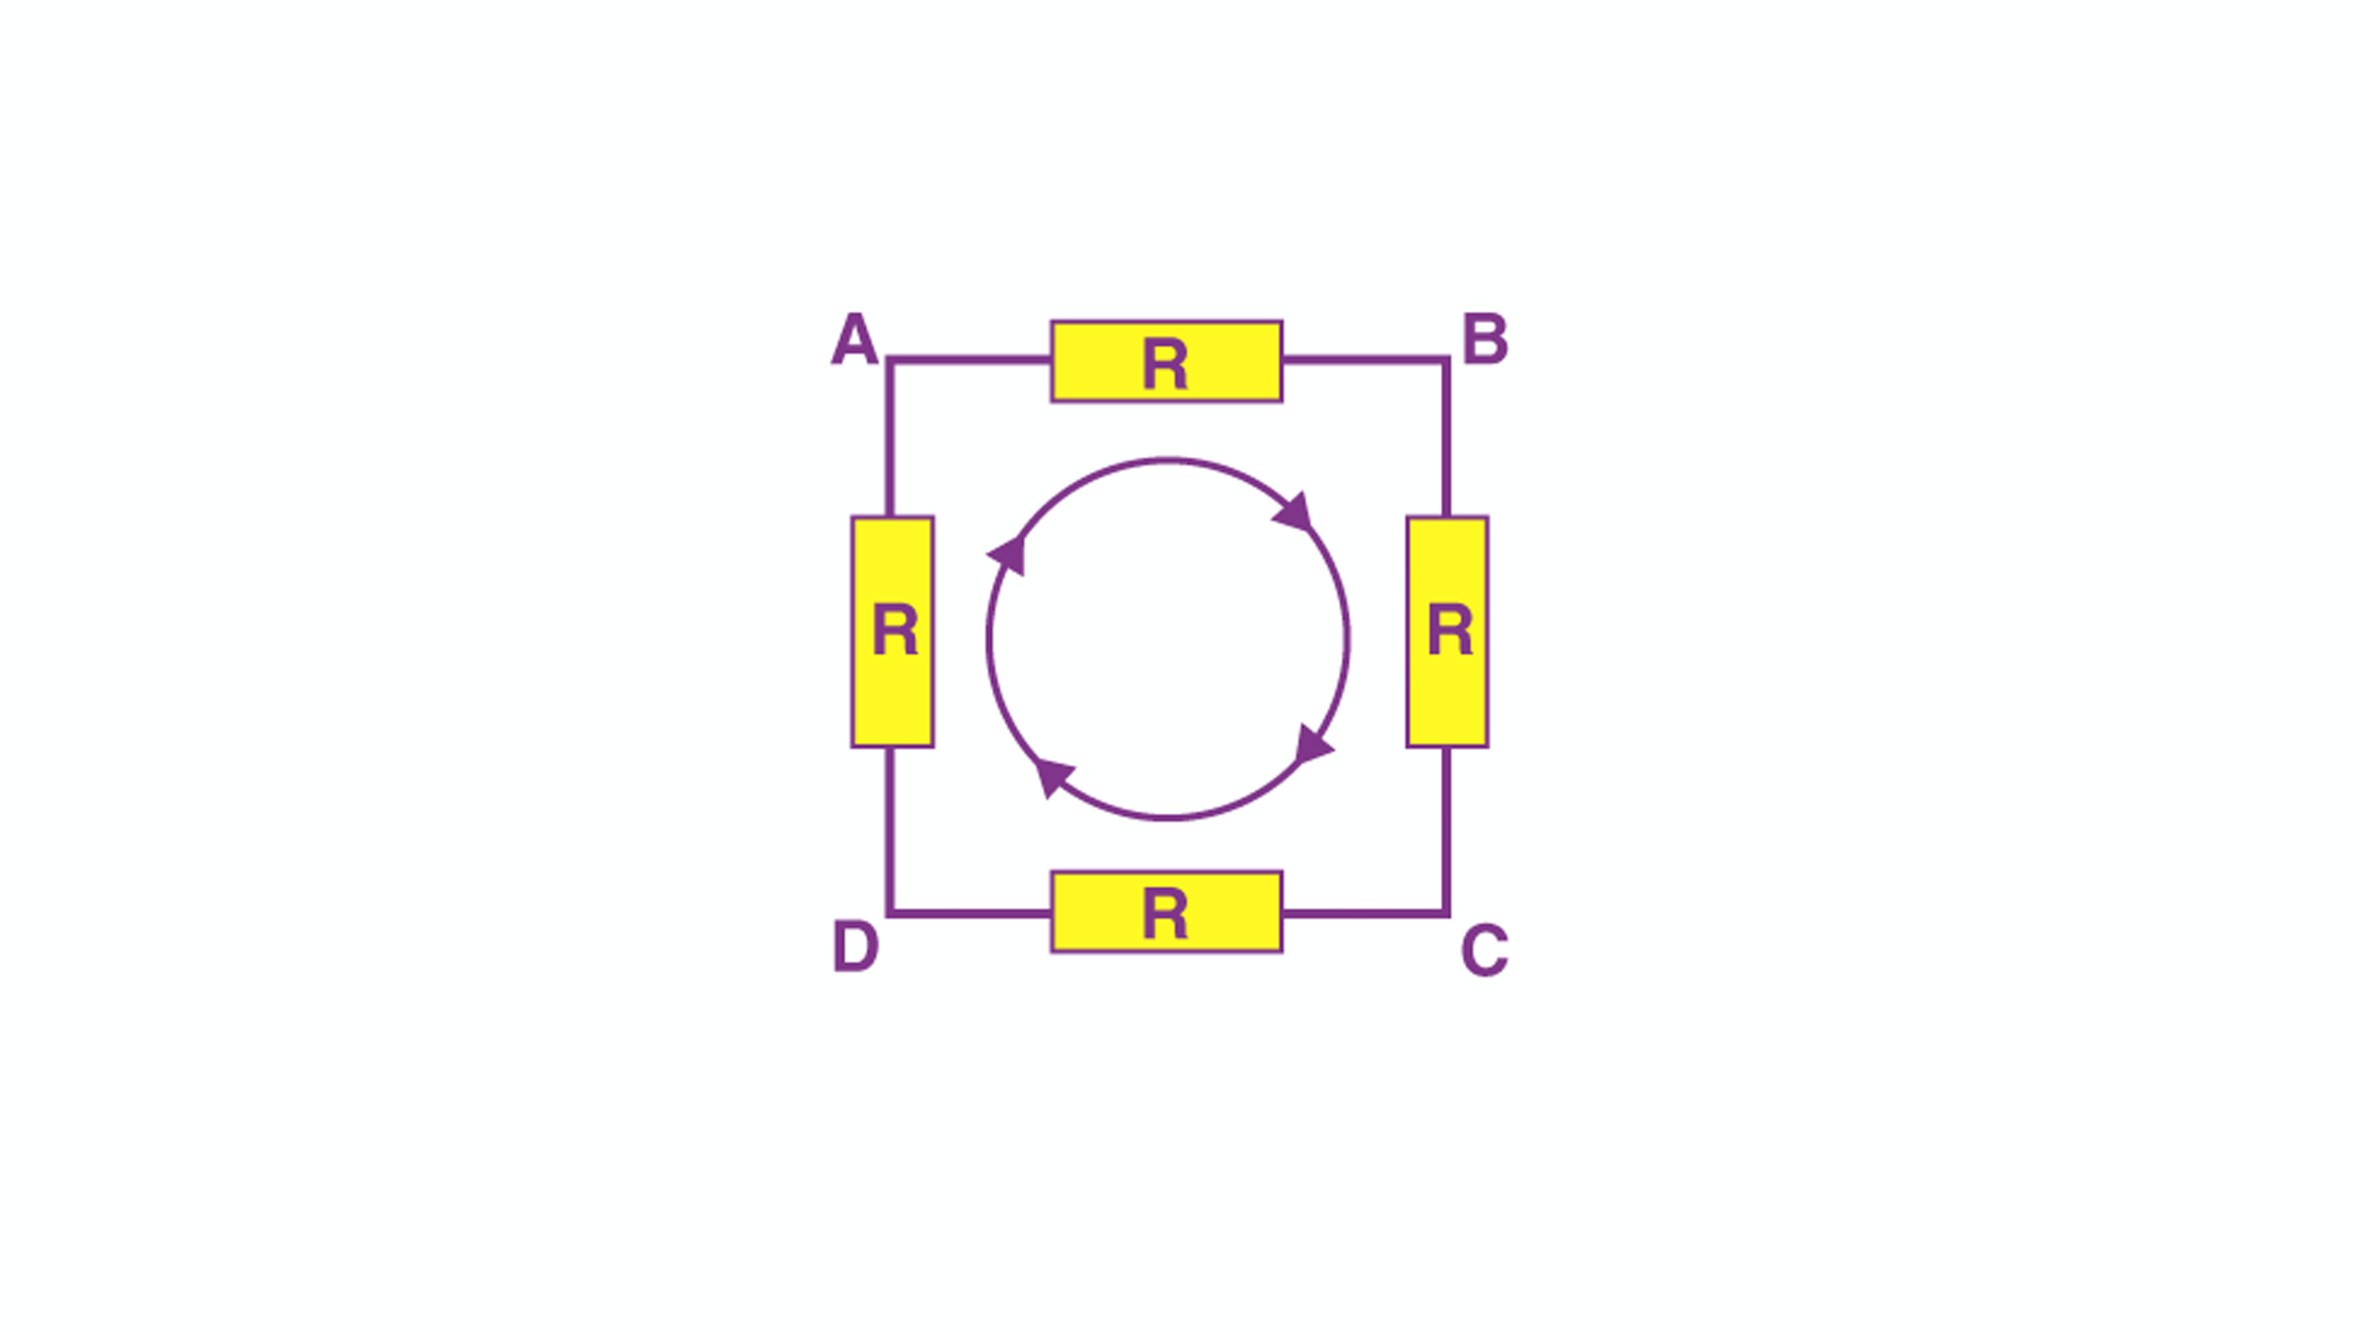

Question 6

a) Explain Superposition Theorem

• The superposition theorem is a circuit analysis

theorem used to solve the network where two or

more sources are present and connected.

• Superposition theorem states the following:

• “In any linear and bilateral network or circuit having

multiple independent sources, the response of an

element will be equal to the algebraic sum of the

responses of that element by considering one

source at a time.”

• The superposition theorem is very important in

circuit analysis because it converts a complex circuit

into a Norton or Thevenin equivalent circuit.

1.How to Apply Superposition Theorem

• The first step is to select one among the multiple

sources present in the bilateral network. Among the

various sources in the circuit, any one of the sources

can be considered first.

• Except for the selected source, all the sources must be replaced by their internal impedance.

• Using a network simplification approach, evaluate the current flowing through or the voltage drop across a particular element in the network.

• The same considering a single source is repeated for all the other sources in the circuit.

• Upon obtaining the respective response for individual

source, perform the summation of all responses to get

the overall voltage drop or current through the circuit

element.

2.Statement of Superposition Theorem

• If two or more voltage or current sources are acting

simultaneously in a linear network, the resultant

current in any branch is the algebraic sum of the

currents that would be produced in it, when each

source acts alone and all other independent

sources are replaced by their internal resistances.

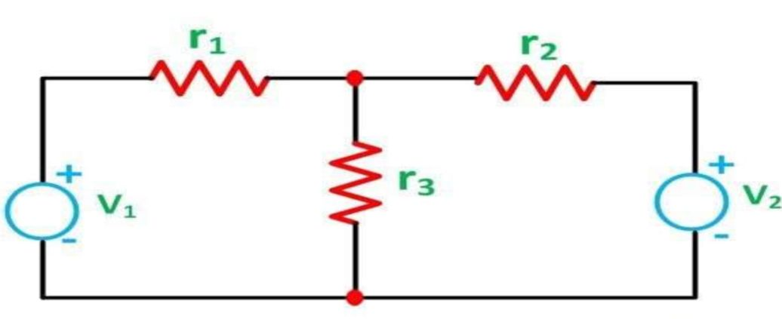

Find v using superposition theorem for the below circuit

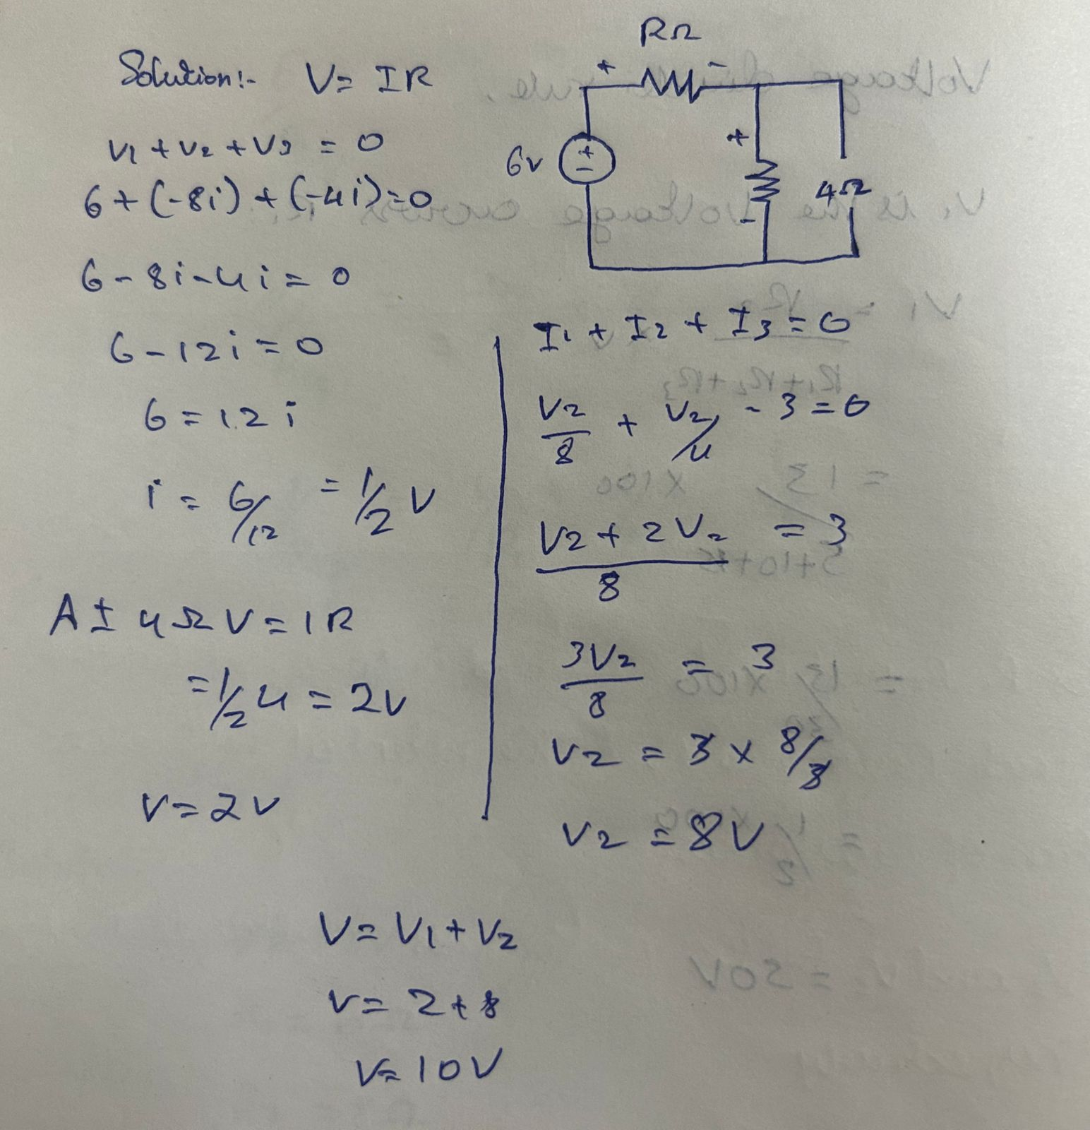

Question 7

a) Explain Source transformation theorem

• Source Transformation technique is very useful for

simplifying the networks or circuits with practical

sources. Whenever there is a possibility and

requirement to apply the Source Transformation

technique for the given circuit, then by applying

this technique first and then use any of the

methods of analysis based on the requirement so

that we can solve the network theory problems

easily.

• This article also discussed the example questions

based on the Source Transformation technique.

• Source Transformation is a technique to convert

one kind of source into other. There are two types

of sources: Voltage source and Current Source.

Therefore, this technique will convert voltage

source into equivalent current source and current

source into equivalent voltage source. This kind of

transformation is required to solve circuit network.

Here, the sources refer to practical source. In this

article, we will discuss the technique of Source

Transformation using some examples

Find Vo using source transformation theorem for the circuit below

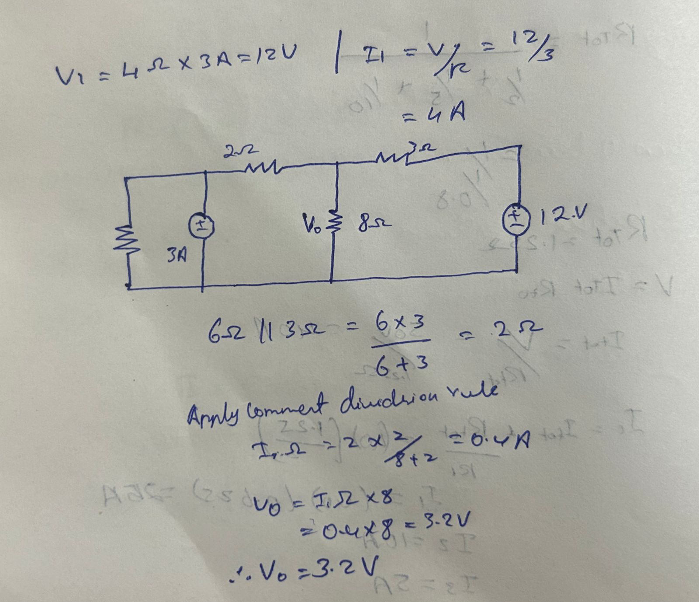

Question 8

Explain the flowing Theorem

**a) Thevenin’s Theorem**

• Thevenin's theorem states that it is possible to simplify any linear circuit, irrespective of how complex it is, to an equivalent circuit with a single voltage source and a series resistance. A Thevenin equivalent circuit is shown in the image

• A Thevenin equivalent circuit is shown in the image. In the image, we see that multiple resistive circuit elements are replaced by a single equivalent resistance Rs and multiple energy sources by an equivalent voltage source Vs.

• Thevenin's theorem states that any 2-terminal

linear and bilateral network or circuit having

multiple independent and dependent sources can

be represented in a simplified equivalent

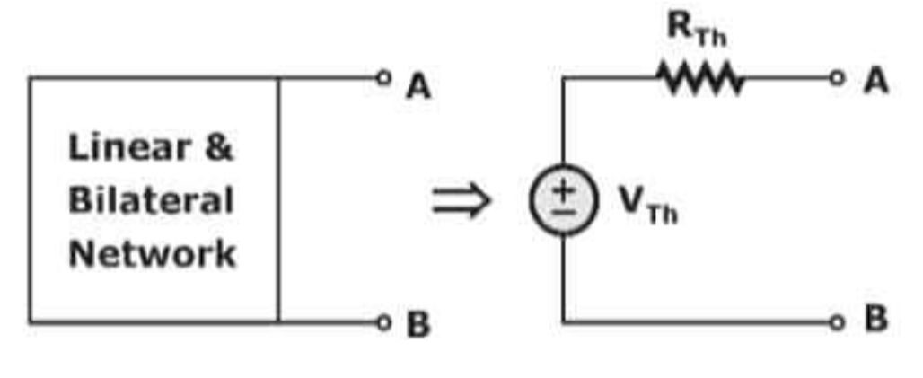

• It will take more time than the normal methods to

find the response of an element if the network/circuit has multiple sources and resistances. However, we can use Thevenin's theorem at that time to find the response easily. Now, let's see the steps for finding the response of an element when multiple sources and resistances are present in the network/circuit by using

Thevenin's theorem

**b) Norton’s Theorem**

• Norton’s theorem allows us to temporarily remove the load resistance from the original circuit of Figure 1 and reduce what’s left to an equivalent circuit composed of a single current source and a parallel resistance.

• Next, the load resistance can then be reconnected to the Norton equivalent circuit to allow calculations as if the whole network is a simple parallel circuit.

• After Norton conversion, our circuit of will be reduced to the Norton equivalent circuit

• Norton's theorem states that any 2-terminal linear

and bilateral network or circuit having multiple independent and dependent sources can be represented in a simplified equivalent circuit known as Norton's equivalent circuit

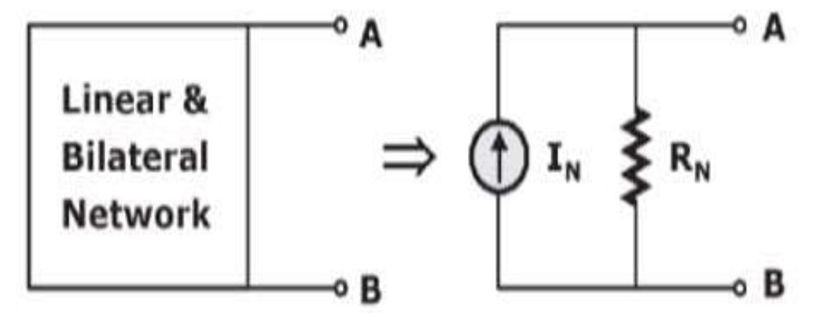

• Norton's equivalent circuit consists of Norton's current source, IN in parallel with Norton's resistance, RN. The parallel the combination of current source and resistor is a practical current source. Hence, we can say that Norton's equivalent circuit is nothing but a practical current source